The SRS Document Development and GitHub paper
Be Huynh
University of Arizona Global Campus
CST499: Capstone for Computer Software Technology
Professor Joseph Rangitsch
February 3, 2025

Software Requirements Specification
for
SRS Document Development
Version 1.0 approved
Prepared by Be Huynh
University Arizona Global Campus-CST499: Capstone for Computer Software Technology
February 3, 2025
eLearning versions of several popular Process Impact training seminars are available at www.processimpact.com/elearning.shtml, including “In Search of Excellent Requirements,” “Exploring User Requirements with Use Cases,” “Writing High-Quality Requirements,” “Software Inspections and Peer Reviews,” and “Project Management Best Practices”. Single-user and corporate-wide site licenses are both available.

Table of Contents ii
Revision History ii
1. Introduction 1
1.1 Purpose 1
1.2 Document Conventions 1
1.3 Intended Audience and Reading Suggestions 1
1.4 Project Scope 1
1.5 References 1
2. Overall Description 2
2.1 Product Perspective 2
2.2 Product Features 2
2.3 User Classes and Characteristics 2
2.4 Operating Environment 2
2.5 Design and Implementation Constraints 2
2.6 User Documentation 2
2.7 Assumptions and Dependencies 3
3. System Features 3
3.1 System Feature 1 3
3.2 System Feature 2 (and so on) 4
4. External Interface Requirements 4
4.1 User Interfaces 4
4.2 Hardware Interfaces 4
4.3 Software Interfaces 4
4.4 Communications Interfaces 4
5. Other Nonfunctional Requirements 5
5.1 Performance Requirements 5
5.2 Safety Requirements 5
5.3 Security Requirements 5
5.4 Software Quality Attributes 5
6. Other Requirements 5
Appendix A: Glossary 5
Appendix B: Analysis Models 6
Appendix C: Issues List 6

Revision History
Name | Date | Reason For Changes | Version
Be Huynh | 2/3/2025 | Add section information | 1.0

Introduction

Purpose
This document is about a Student Course Enrollment System. The system helps students sign up for courses, manage their schedules, and join waiting lists if a class is full. It also includes creating user profiles and logging in. This document explains the basic features of the system, like registering for courses and managing waiting lists. It doesn't cover other parts of the system that may be added later, such as features for instructors or reports. This is the first version of the system.

Document Conventions
The SRS uses simple formatting for easy reading. We use times new roman font, size 12, and bold for headings. For the requirements, the more important ones, like registration and course enrollment, have a higher priority. Each requirement also has its own priority to make sure the most important features are done first.

Intended Audience and Reading Suggestions
This SRS document is for different readers like developers, project managers, testers, and users. Developers will focus on how the system should work, project managers will look at the goals and scope, testers will use it to check if the system works right, and users will see how to use it. The document is organized into an overview of the system, system requirements, non-functional requirements, and appendices. To read it, start with the overview for a general idea, then look at the system requirements for how it works, and testers can focus on the non-functional requirements.

Project Scope
This software is a system for students to register for courses and manage their schedules online. It helps students easily find and enroll in courses and manage waiting lists if courses are full. The goal is to make registration faster, more accurate, and easier for everyone. It supports the school’s goal of improving the course registration process.

References
Title: Google Material Design Guidelines
Author: Google
Date: Accessed February 2025
Source: https://m3.material.io/nts

Title: UML Use Case Diagram Examples
Author: Kirill Fakhroutdinov
Date: Accessed February 2025
Source: https://www.uml-diagrams.org/use-case-diagrams-examples.html

Overall Description

Product Perspective
This system is a new product designed for students to enroll in courses online. It's not replacing anything, but it is a brand-new tool to make signing up for classes easier. The system is part of a larger Student System that manages different parts of student information, but its main job is to handle course enrollment. It will connect to other systems, like student records and course details, to share information. A simple diagram can show how this system links with other systems or tools it uses.

Product Features
The system allows users to register with a unique ID and password, view and enroll in courses for different semesters, and join a waiting list if a course is full. Students can also cancel their course enrollment, and if someone cancels, the system will notify the next person on the waiting list. Users can update their profiles with details like their name, phone number, and email. These features work together to make the course enrollment process easy and flexible for students.

User Classes and Characteristics
The system is for three main user groups: students, administrators, and system support. Students are the main users and will use the system to sign up for classes, check schedules, and manage their profiles. Administrators manage the courses and student registrations and have more control over the system. System support users handle technical issues and help keep the system working. The system should focus mostly on meeting the needs of students, followed by administrators and system support.

Operating Environment
The software will run on the internet, so users can access it through browsers like Google Chrome, Firefox, and Microsoft Edge. The student course enrollment system should be designed to work on all major web browsers and be mobile-friendly, ensuring accessibility and smooth functionality on both desktop and mobile devices.

Design and Implementation Constraints
The development of the student course enrollment system will follow company policies on security, privacy, and accessibility. It must integrate with existing systems and meet legal requirements. Developers will use specified technologies, secure communication methods, and adhere to coding standards and security guidelines.

User Documentation
The user documentation for the system will include a user manual, online help, and tutorials. The manual will be in PDF format, and online help will be available within the system. Tutorials will be provided as videos and text instructions to make it easy for users to understand how to use the system

Assumptions and Dependencies
The project assumes that third-party tools and components will work as expected and that users will have access to modern web browsers and mobile devices. It also depends on external software, like payment services or authentication systems, which may affect the project if they have issues. Any changes in these assumptions could impact on the project's requirements or timeline.

System Features
This section groups the system’s features by user type, showing the key services each user can access. It helps explain how the system works for different users, making it easier to understand.

System Feature 1
3.1.1 Description and Priority
Priority: High
This feature allows students to sign up for courses each semester, which is essential for managing their academic schedule.
3.1.2 Stimulus/Response Sequences
Stimulus: The student selects a course and clicks on "Enroll."
Response: The system checks if the course has space. If yes, it confirms the enrollment. If the course is full, the system asks if the student wants to join the waiting list.
3.1.3 Functional Requirements
REQ-1: The system should list courses for each semester.
REQ-2: The system must allow enrollment if the course has available spots.
REQ-3: If the course is full, the system should offer to add the student to the waiting list.
REQ-4: The system must show an error if the student tries to enroll in an invalid course.

External Interface Requirements

User Interfaces
The student course enrollment system will have a simple interface that works on all devices and browsers. Users can easily access their profile, courses, and enrollments. Action buttons like "Enroll," "Cancel," and "Help" will be available, with keyboard shortcuts for easy navigation. Clear error messages will guide users, and the design will be consistent throughout.

Hardware Interfaces
The system will work on devices like computers and phones. It will connect to servers to store and get data. The system will use standard internet connections (HTTP and HTTPS) to make sure data is transferred securely. This will help with tasks like signing up for courses, updating profiles, and processing payments.

Software Interfaces
The system will use a MySQL database to store student and course data. It will run on Windows with a web server like Apache. The front end will be built with HTML, CSS, and JavaScript. Data like student info and payments will be sent to and from the system. The system will also connect to a payment service via APIs to handle transactions. Data will be shared between the front end and database to keep everything updated.

Communications Interfaces
The system will use email to notify users about actions like signing up, enrolling in courses, and cancellations. It will communicate with users through web browsers using HTTPS for secure connections. The system will also use APIs to connect with external services, such as payment systems. Data will be securely encrypted during transfer. Emails will be sent in HTML or plain text format for easy reading.

Other Nonfunctional Requirements

Performance Requirements
The system should be loaded in under 2 seconds. When a user enrolls or drops a course, the update should happen immediately. It should take less than a minute for a new user to create an account. Search results should appear in 3 seconds, and confirmation messages should show in 3 seconds or less. Fast performance is important for smooth user experience and to reduce work at the Registrar’s Office.

Safety Requirements
The system must protect user data with encryption and prevent unauthorized access. It should avoid issues like data breaches or crashes. The software must follow data protection laws like GDPR and meet necessary safety standards.

Security Requirements
The system must keep user data safe and private. Users should log in with a secure method, like a password or two-step verification. The product must follow privacy laws like GDPR and meet security standards. The GDPR defines important terms like personal data (any information that can identify someone, such as names or email addresses), data processing (any action with data, like collecting or deleting it), data subject (the person whose data is processed), data controller (the person who decides how personal data is used), and data processor (a third party that handles data on behalf of the controller, like cloud services or email providers).

Software Quality Attributes
The product should be easy to use, reliable, and work well with other systems. It must be available 99.9% of the time and support future updates. It should be simple to test, fix, and adapt to different devices. Usability is a top priority for ease of learning.

Other Requirements
No additional requirements are necessary.
Appendix A: Glossary
SRS: Software Requirements Specification.
HTTP: HyperText Transfer Protocol.
HTTPS: HyperText Transfer Protocol Secure.
HTML: HyperText Markup Language.
CSS: Cascading Style Sheets.
API: Application Programming Interface.
GDPR: General Data Protection Regulation.
Appendix B: Analysis Models
No further requirements are needed at this time.
Appendix C: Issues List
No further requirements are needed at this time. Review.

The UML Design Modeling paper
Be Huynh
University of Arizona Global Campus
CST499: Capstone for Computer Software Technology
Professor Joseph Rangitsch
February 10, 2025

In software development, testing is a very important step to ensure that the software works properly and meets the needs of the users. The main goal of testing is to find any issues or bugs early so that they can be fixed before the software is released. There are different types of testing, and each one checks a different part of the software. The four main types of testing are component testing, integration testing, system testing, and acceptance testing. Each level of testing has its own job to make sure the software works smoothly from start to finish.
Component testing, also known as unit testing, is the first level of testing. It focuses on the smallest parts of the software, like a single function, button, or piece of code. The goal is to make sure that each part works correctly on its own. For example, if there is a calculator feature in the software, the developer might test if the “add” function correctly adds numbers together. This helps find and fix issues with individual parts before they are combined with other parts. If something is wrong at this level, it is easier to fix because it is isolated to just one small piece.
Once the individual components have been tested, the next step is integration testing. This type of testing checks if different parts of the software work together properly. For example, in an online shopping website, integration testing would check if the shopping cart is correctly connected to the payment system. If a user adds an item to their cart and goes to the checkout, integration testing makes sure that the cart and the payment system work smoothly together. This testing ensures that the parts, when combined, communicate correctly and that there are no issues when they interact with each other.
System testing looks at the entire software as a whole. This is when the software is tested to see if everything works as expected in real-life situations. For example, system testing would check if a user can log in, browse the website, add items to the cart, and make a purchase without any problems. It makes sure all the parts of the software are working together and that the system performs well under normal and different conditions. System testing ensures that the software does what it’s supposed to do when used by real users.
The final level of testing is acceptance testing. This is the step where the software is tested by real users or stakeholders to see if it meets their needs and requirements. Acceptance testing is done to make sure the software is not only functional but also easy to use and provides the features that users expect. For example, a group of users might test the software to see if it’s easy to navigate, if all the features work as expected, and if they are satisfied with the overall experience. If anything is wrong or doesn’t meet the user’s expectations, it can be fixed before the software is released to the public.
In conclusion, testing is a key part of software development because it ensures that the software works correctly and meets the needs of the users. By testing the small parts first (component testing), then checking how the parts work together (integration testing), testing the whole system (system testing), and finally making sure the software meets user needs (acceptance testing), developers can find and fix problems before the software is released. This helps make sure that the final product is reliable, user-friendly, and ready for use. Testing at each of these levels is essential for creating high-quality software that performs well and is easy for users to interact with. In the end, a well tested software product not only reduces the risk of failures but also builds trust with users, ensuring they have a positive experience with the software.

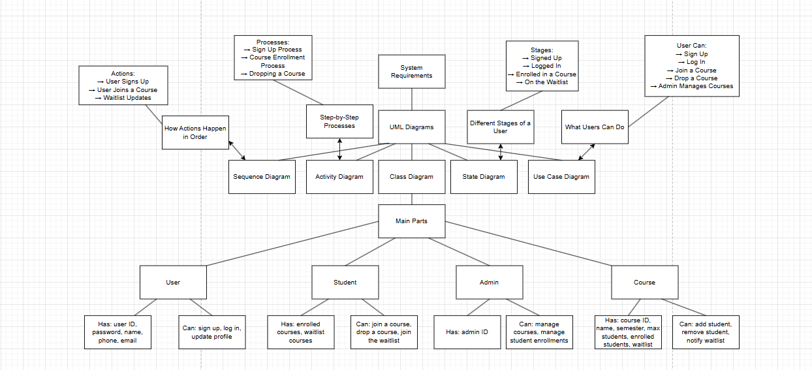
UML diagrams

Landing, Login, and Enrollment Pages Development
Be Huynh
University of Arizona Global Campus
CST499: Capstone for Computer Software Technology
Professor Joseph Rangitsch
February 17, 2025

Introduction
Running PHP files in XAMPP is a simple way to build and test web applications on your computer. XAMPP includes Apache, MySQL, and PHP, making it easy to run PHP projects. In this guide, I'll show you how to set up PHP, create a registration page for new users, and save their information in a MySQL database. I will also explain how to create a custom class to manage the database connection.
How to Run a PHP File in XAMPP
To run a PHP file in XAMPP, the first step is to download and install XAMPP from its official website. Once installed, open the XAMPP Control Panel and start both the Apache and MySQL services. These services are necessary to run PHP and interact with the database. Next, create a PHP file using a text editor like Notepad++ or Visual Studio Code, and save it with a .php extension (e.g., index.php). After that, move the file to the htdocs folder in the XAMPP directory. To see your file in action, open a web browser and go to http://localhost/index.php.

Create the landing page, login page, and registration page for new users.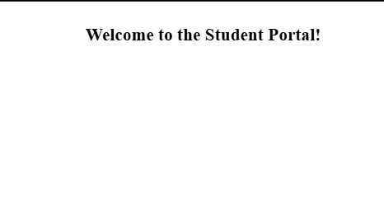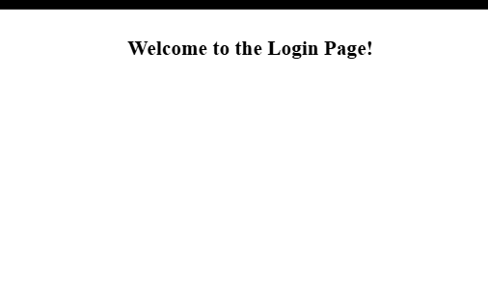
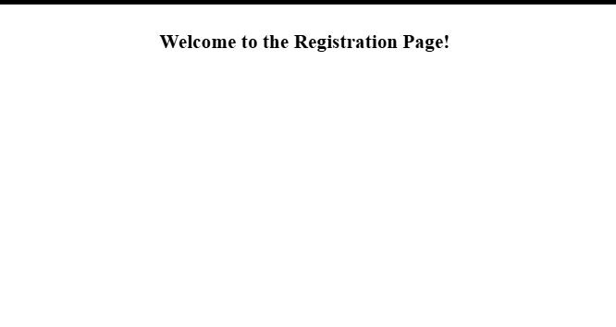
Discuss the MySQL database functions that you used and the steps you took to create the database connection custom class.
To connect PHP to a MySQL database, use the mysqli_connect() function. This function requires the database server (usually localhost), the username (often root), the password, and the database name. The connection is stored in a variable like $conn, which you can later use to perform database operations. If the connection fails, an error message will be shown. You can also create a custom class to handle database connections, making your code more organized and reusable. This class can include methods to open the connection, close it, and run queries, making it easier to maintain your code.

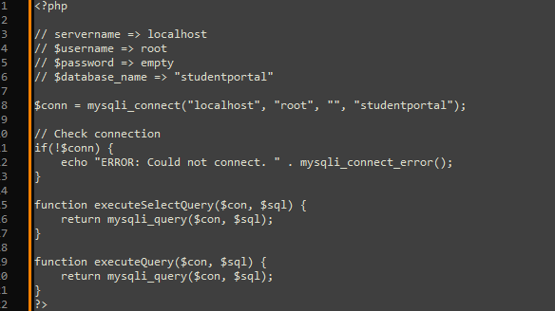

Develop the registration page layout.
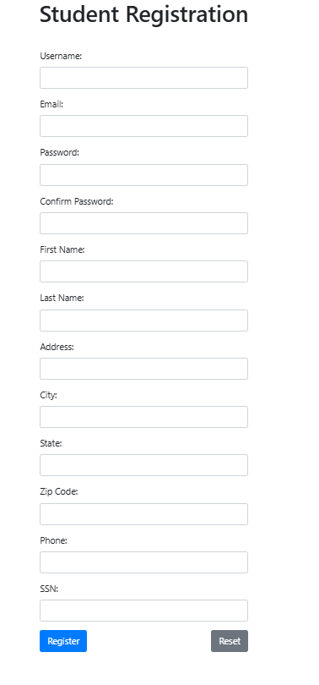
Develop the registration page PHP source code.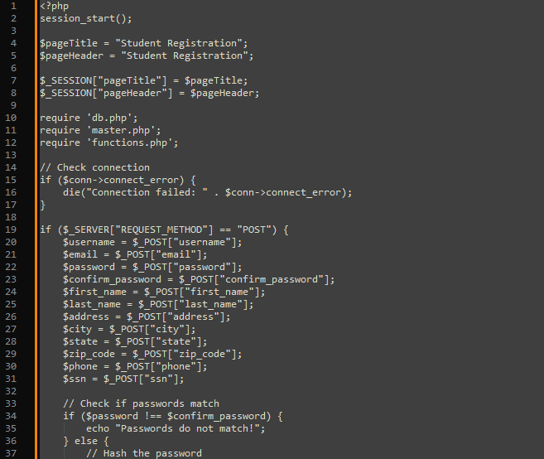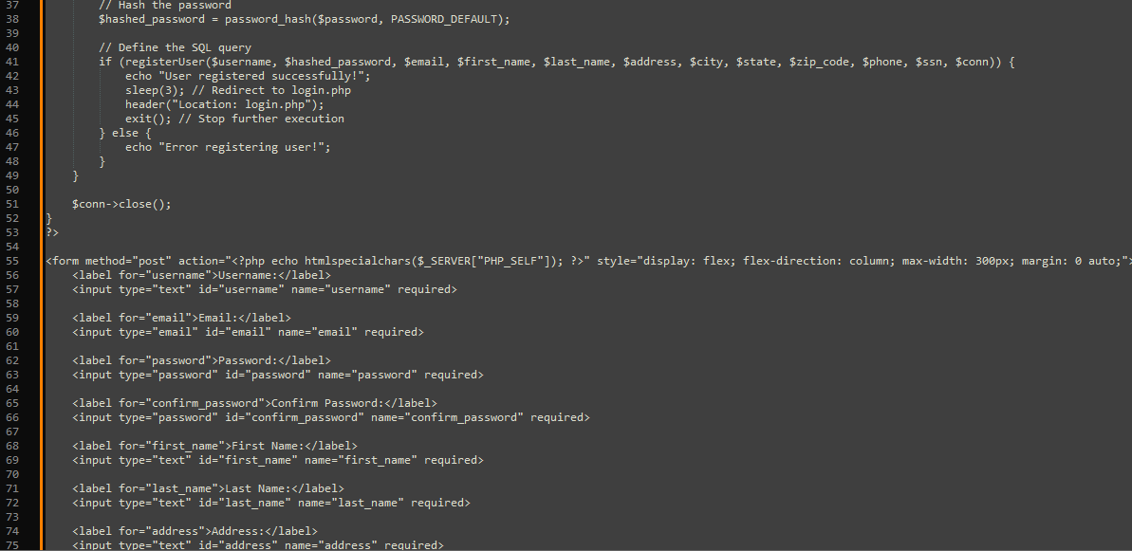
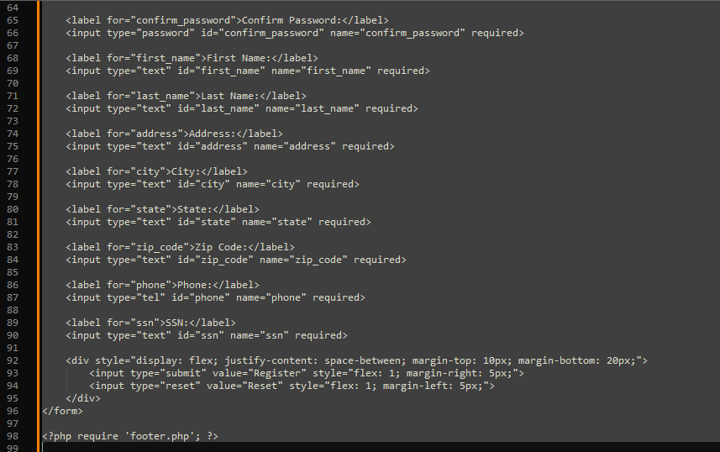
Develop the table that saves the user information in the database.
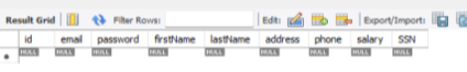
Explain the steps taken to create the registration page and save the user information in the database.
The first step involved creating a form on the registration page to send data to the insert.php page. The form includes labels and input fields for each required piece of information, along with a submit button. Upon clicking the submit button, the form data is sent to insert.php. The script connects to the database, assigns the submitted values to variables, and then inserts those values into the database.
Provide screenshots of all developed pages, database, tables, layout, and source code.
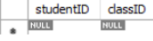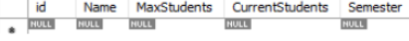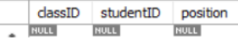

login
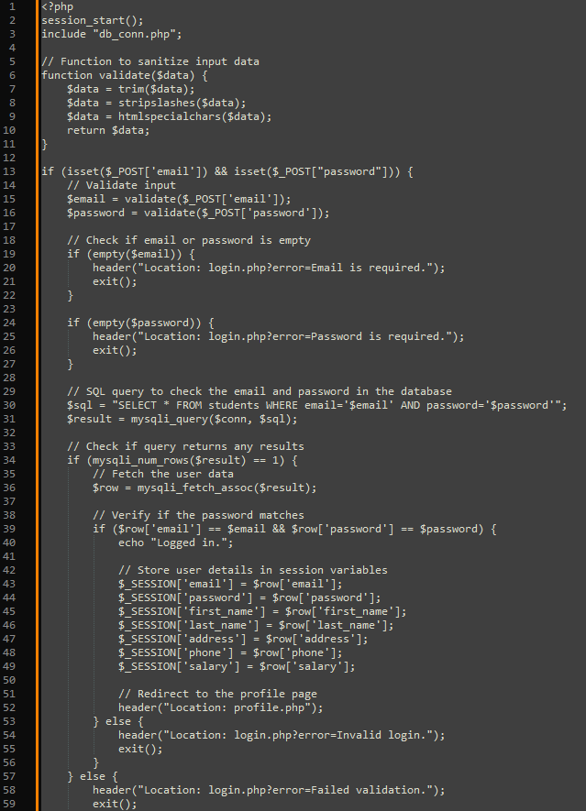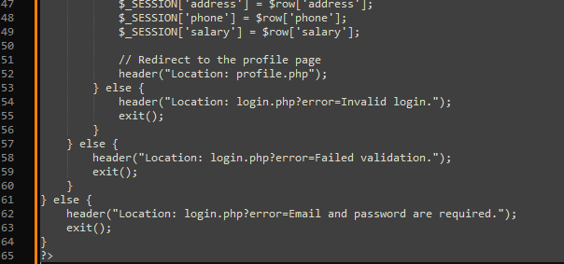
Profile
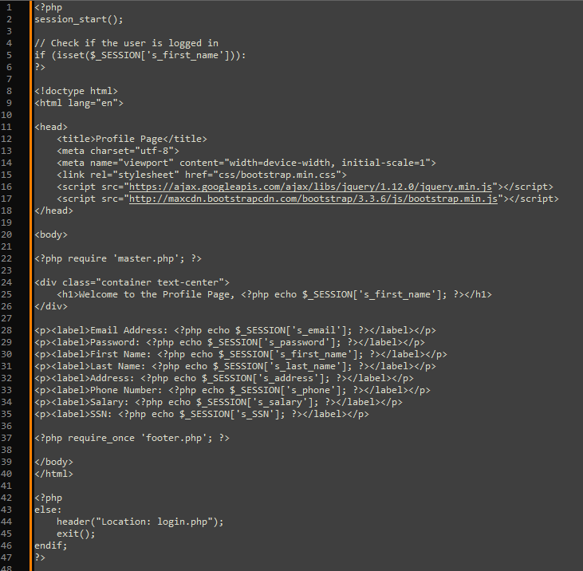
Student Portal
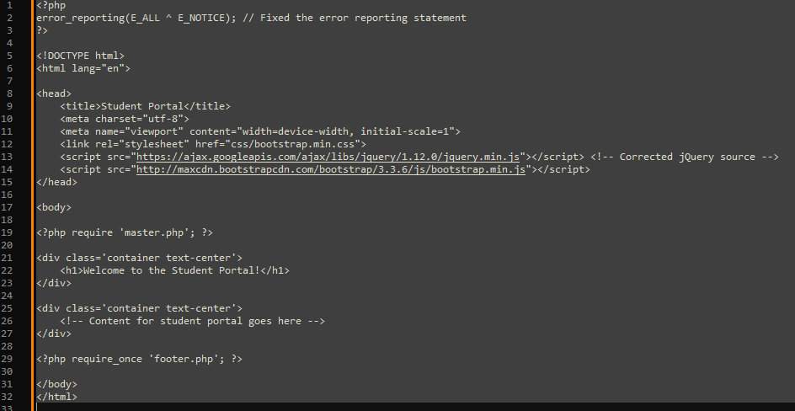

Logout

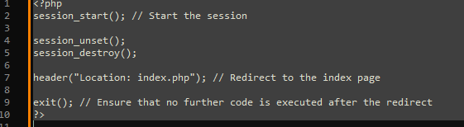

Conclusion
In conclusion, setting up PHP in XAMPP and developing a registration system was both challenging and a valuable learning experience. Although building the pages and saving user data in MySQL took time and caused some confusion along the way, the process was ultimately rewarding. By utilizing mysqli_connect() and creating a custom class for database connections, I gained a deeper understanding of working with databases. While it was a tough task, it was a great opportunity to grow and improve my skills as a developer.

The Database Development and Class Registration
Be Huynh
University of Arizona Global Campus
CST499: Capstone for Computer Software Technology
Professor Joseph Rangitsch
February 24, 2025

Introduction
This assignment was focused on creating a class registration system. I worked on setting up a database and making sure everything worked properly. The main goal was to allow students to register for classes, manage their schedules, and join waitlists if needed. I created MySQL tables to store data, connected them to the website, and added important features like login and class registration.
Create your tables within the MySQL database related to rest of your design.
All the necessary tables were created at the beginning. The classes table lists all available classes with details. The students table stores student information, including login details. The registrations table links students to their enrolled classes. The waitlist table keeps track of students waiting for a class.
Create the different pages related to the rest of the requirements and the design per your work in Week 1 and Week 2.
After registration and login, the last page to create was the student portal page. This page lets students sign up for classes. If a class is full, they are added to the waitlist. If there is space, they are enrolled, and the student counts updates. When a student drops a class, they are removed, and the student count adjusts. If there are students on the waitlist, the next one in line gets enrolled, and the waitlist updates. If a student leaves the waitlist, they are removed, and the list shifts to fill the gap.

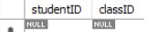


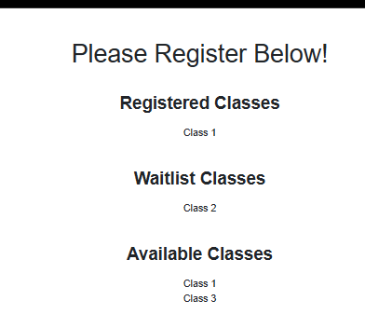
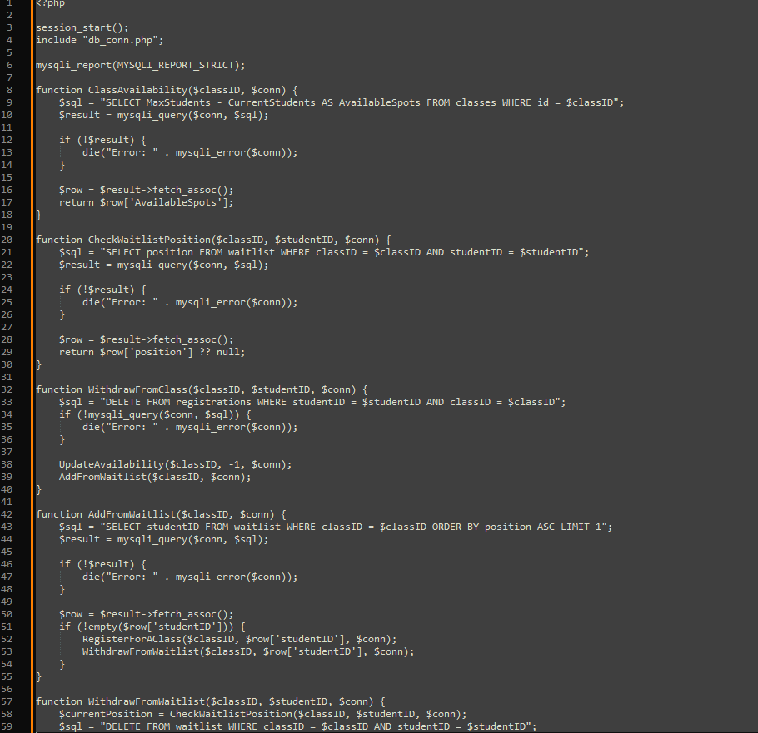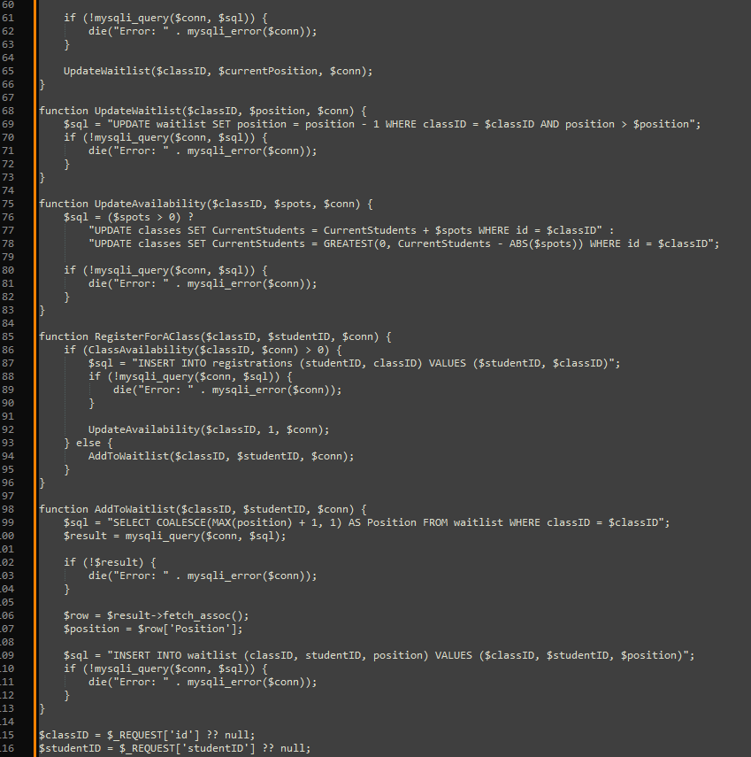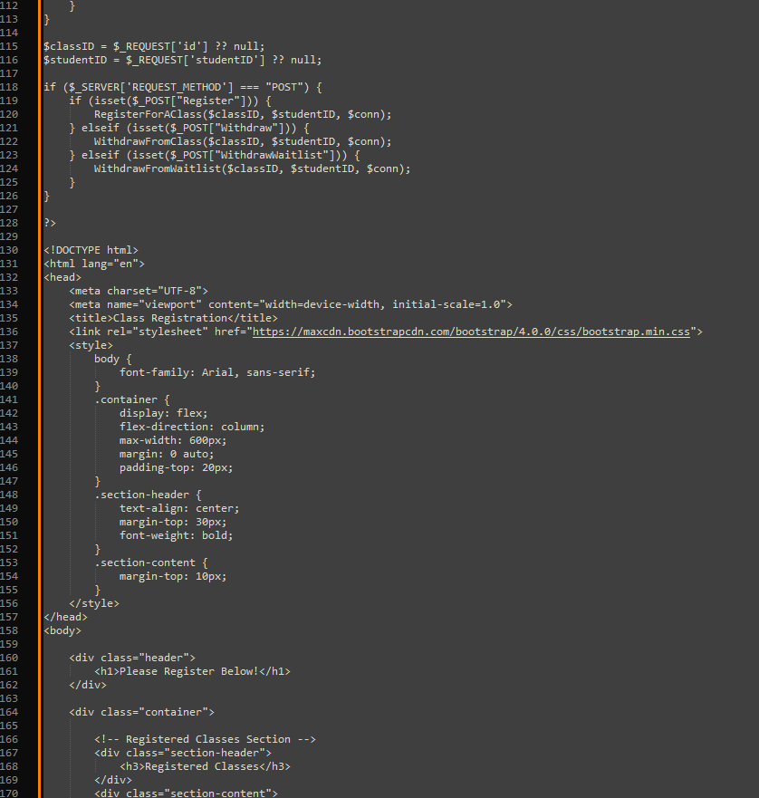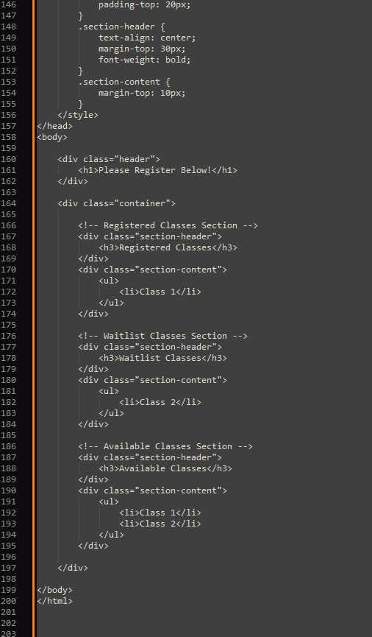

login

Profile
Student Portal

Logout

Summarize your experience going through the implementation phase.
The implementation phase was a good learning experience. I started by creating the database tables and linking them to the website. Then, I set up the registration and login features so students could use the system. The Student Portal page was important because it let students sign up for classes, join waitlists, and drop classes. I tested it to make sure everything was updated correctly in the database. There were some challenges, like fixing database connection errors and making sure the pages showed the right information. Debugging took a lot of time, but it helped me understand MySQL and PHP better. Overall, it was great to see everything work. These assignments helped me learn how to build a system and use databases.
Conclusion
This assignment was a valuable learning experience. It helped me improve my skills in using MySQL and PHP. While working on the system, I faced some challenges, like fixing errors and making sure the data updated correctly, but solving these problems made the project more rewarding. In the end, seeing the system work as expected boosted my confidence in building functional and useful systems.

References

Course enrolment - MoodleDocs. (n.d.). https://docs.moodle.org/405/en/Course_enrolment
Differences between the different levels & types of testing. (2023, August 24). Reqtest. https://reqtest.com/en/knowledgebase/different-levels-of-testing/
GeeksforGeeks. (2024, February 25). Levels of software testing. GeeksforGeeks. https://www.geeksforgeeks.org/levels-of-software-testing/
GeeksforGeeks. (2024, June 5). How to insert form data into database using PHP? GeeksforGeeks. https://www.geeksforgeeks.org/how-to-insert-form-data-into-database-using-php/
GeeksforGeeks. (2020, November 2). PHP database connection. GeeksforGeeks. https://www.geeksforgeeks.org/php-database-connection/
How Fast Should A Website Load? (n.d.). Retrieved February 3, 2025, from https://Https://pagespeedchecklist.com/load-time-goals
Hosting, S. W. (2021, August 17). PhpMyAdmin database management tutorial. SiteGround. https://www.siteground.com/tutorials/phpmyadmin/database-management/
Menon, K. (2024, July 10). PHP with MySQL: Ultimate step-by-step guide. Simplilearn.com. https://www.simplilearn.com/tutorials/php-tutorial/php-with-sql
Tsui, F., Karam, O., & Bernal, B. (2018). Essentials of software engineering (4th ed.). Jones & Bartlett Learning.
Wolford, B. (2024, August 29). What is GDPR, the EU’s new data protection law? GDPR.eu. https://gdpr.eu/what-is-gdpr/

